ELYON KINDERGARTEN SCHOOL.
END OF TERM II EXAMINATION 2025.
CLASS: MIDDLE AGE: 4 – 5
LEARNING AREA 5 SUBJECT: ENGLISH
NAME:________________________________ CLASS:_____________
- Fill in the missing letters.

a b c ____ e _____ g ____ i ____ k _____

m ____ o ____ q _____

- Circle the correct word.

sun uns

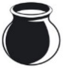
top pot

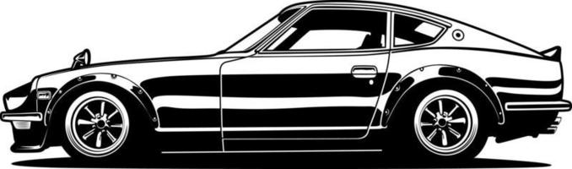
car rca

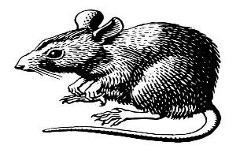

tar rat

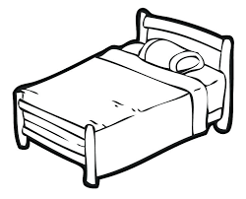
bed bde

- Write the letter after.

a b c _____ e ____

g _____ s _____ x ____

f _____ m ____ o ____

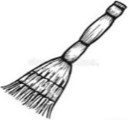
- Fill in the missing letters.
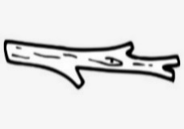
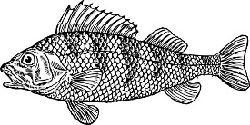
br ___ ___ m f __ sh st _i_ ck
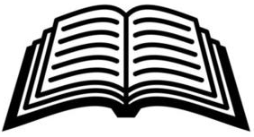
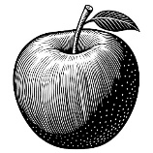
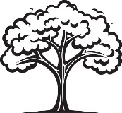
tr ___ ___ appl ___ b __ __ k

- Name the pictures.
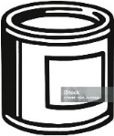
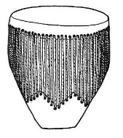
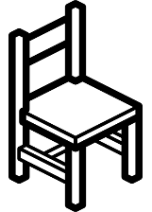
__________ _________ _________
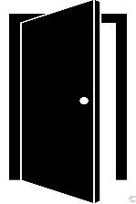
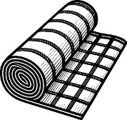
__________ _________ ________

{chair, bell, drum, mat, tin, door}

- Write the letters correctly.
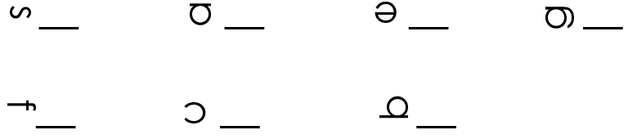

- Complete the sentences.
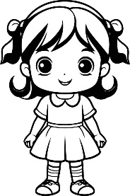
This is a girl.

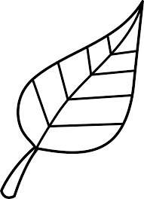
This is a __________.


This is a ____________.
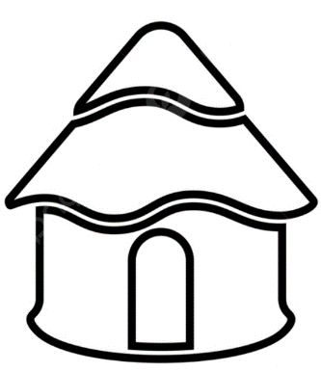

This is a ___________.

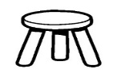
This is a ___________.
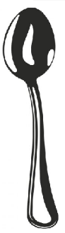

This is a __________.

{flower, girl, stool, hut, spoon, leaf}

END

